Department of Training and Placement,
SLIET Longowal

In recent years, SLIET Longowal (Deemed to be University) have done commendably well in enhancing placement of our student in top MNC’s, private & public enterprises. About 60-80 organizations from various sectors, like IT, FMCG, Manufacturing, Telecom, Constructions, Automobile, Pharmaceuticals, Food & Beverages, Infrastructure, Power, Chemical & Fertilizer and Consultancy etc., visited/ provided opportunities & placed our students during years 2016-2018. Some of our esteemed recruiting organizations include are listed below:
SOME OF OUR RECRUITERS
S.NO. | NAME OF THE COMPANY
1 | GE INDIA INDUSTRIAL PVT. LTD., PUNE
2 | HINDUSTAN UNILEVER INDIA
3 | TRIDENT GROUP
4 | GODREJ & BOYCE MFG. CO. LTD | 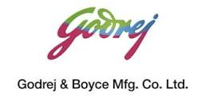
5 | MARUTI SUZUKI INDIA LTD., GURGAON
6 | BHARAT PETROLEUM CORPORATION LTD
7 | TATA CONSULTANCY SERVICES
8 | HP INDIA PVT. LTD
9 | ISGEC HEAVY ENGINEERING LTD
10 | AMAZON
11 | INDIAN ARMY | 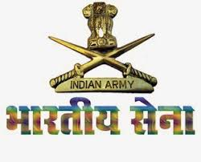
12 | INDIAN NAVY | 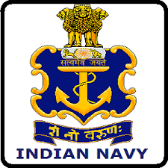
13 | HONDA CARS INDIA LIMITED
14 | LARSEN & TOUBRO
15 | VARDHMAN TEXTILES LTD | 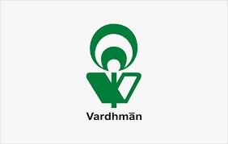
16 | NESTLE INDIA LTD.
17 | SOFTWARE AG
18 | TATA PROJECTS LIMITED
19 | INTERNATIONAL TRACTORS LTD. (SONALIKA GROUP)
20 | JOHNSON CONTROLS BUILDING TECHNOLOGIES AND SOLUTIONS.
21 | BYJU'S
22 | ADOBE SYSTEMS, INDIA
23 | NEC TECHNOLOGIES | 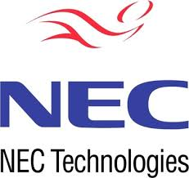
24 | DIRECTI INTERNET SOLUTIONS PVT LTD.
25 | NIIT TECHNOLOGIES
26 | ASIAN PAINTS PVT LTD | 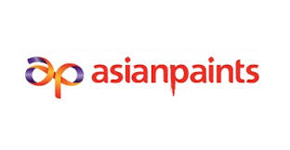
27 | JCBL GROUP, CHANDIGARH
28 | CHANDIGARH DISTILLERS & BOTTLERS LTD | 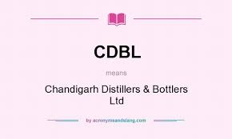
29 | VSERV BUSINESS SOLUTIONS PVT. LTD
30 | KANDHARI BEVERAGES PVT. LTD (COCA COLA)
31 | JUBLIANT FOODWORKS, MOHALI
32 | VIRTUSAPOLARIS, HYDERABAD
33 | INDSOFTRE PVT. LTD., NOIDA
34 | RALSON GROUP | 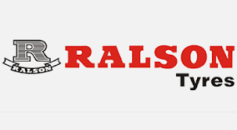
35 | EBIZON NETINFO PVT. LTD., NOIDA
36 | ECLERX SERVICES LTD., CHANDIGARH
37 | OM CAREERS, LUDHIANA
38 | PYRAMID IT CONSULTING, MOHALI
39 | BAANI MILK PRODUCERS
40 | GURU NANAK AUTO ENTERPRISES LTD, PHAGWARA
41 | INTERSOFT PROFESSIONAL PVT LTD
42 | NEW SWAN GROUP, LUDHIANA | 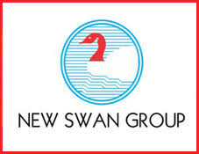
43 | SOPRA STERIA, NOIDA
44 | WEBASTRAL MOHALI
45 | SHRI RAM PANELS PVT LTD
46 | CLAAS INDIA PVT LTD | 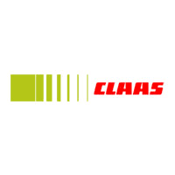
47 | POLESTAR SOLUTIONS & SERVICES INDIA PVT. LTD.
48 | EASTMAN CAST & FORGE LTD | 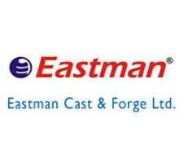
49 | CORPUS MEDIA LABS
50 | GREY ORANGE INDIA PVT. LTD. GURGAON
51 | GARTNER INDIA | 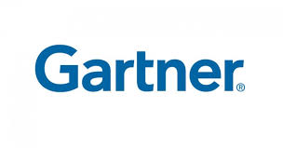
55 | BRAVURA SOLUTIONS LIMITED
56 | GREENPLY INDUSTRIES LTD
57 | SUCCESSIVE SOFTWARE
58 | ACADEMIAGURU

But not limited to…………………
Year | Average Salary | Highest Salary
2016-2017 | 3.20 LPA | 15 LPA
2017-2018 | 3.50 LPA | 09 LPA (as on date)

Head
Department of Training & Placement

